Problem:
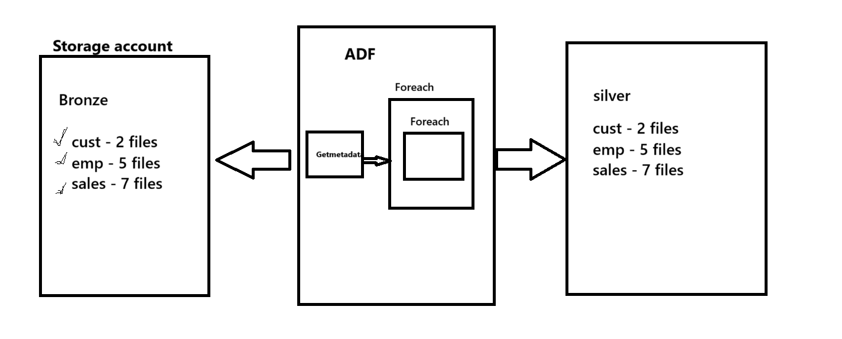
Solution:
Implement a nested ForEach pipeline and append a date to all files in storage using a master-child pipeline relationship in Azure Data Factory (ADF)
Scenarios:
- How to copy data from ADLS Gen2 Bronze container to Silver folder
- How to pass parameters from master pipeline to child pipelines
- How to call one pipeline from another pipeline
- ADF doesn’t support Nested For Each, but how to achieve it
- Get Metadata Activity
- For Each Activity
- Execute Pipeline Activity
- Copy Activity
Logic:
Step1: create two pipelines, one is master pipeline another one is child pipelines
Step2:
Master pipeline adds get metadata activity the reason is to get the folder from bronze container, make sure child, select items option in get metadata activity
Add for each activity to iterate the folders, inside add one more activity called execute pipeline activity, inside execute pipeline activity there is option called invoked pipeline, here select your child pipeline
What every you created pipeline parameter under child pipeline provide the value as a @item().name ,here name is get metadata activity gives the folders information

Step3: in Child pipeline add first activity called getmetadata activity. here getmetadata activity intension is to get files information, these files information which is provided by the pipeline parameter.
Here condition is creating dataset parameters for getmetadata activity pass the value as a pipeline parameter.
Once you add this step , if you run the pipeline here we are getting only files.

Next activity is foreach to iterate the files.
Inside foreach activity add copy activity
Create dataset parameters for source and sink and pass the folder value as pipeline parameter .

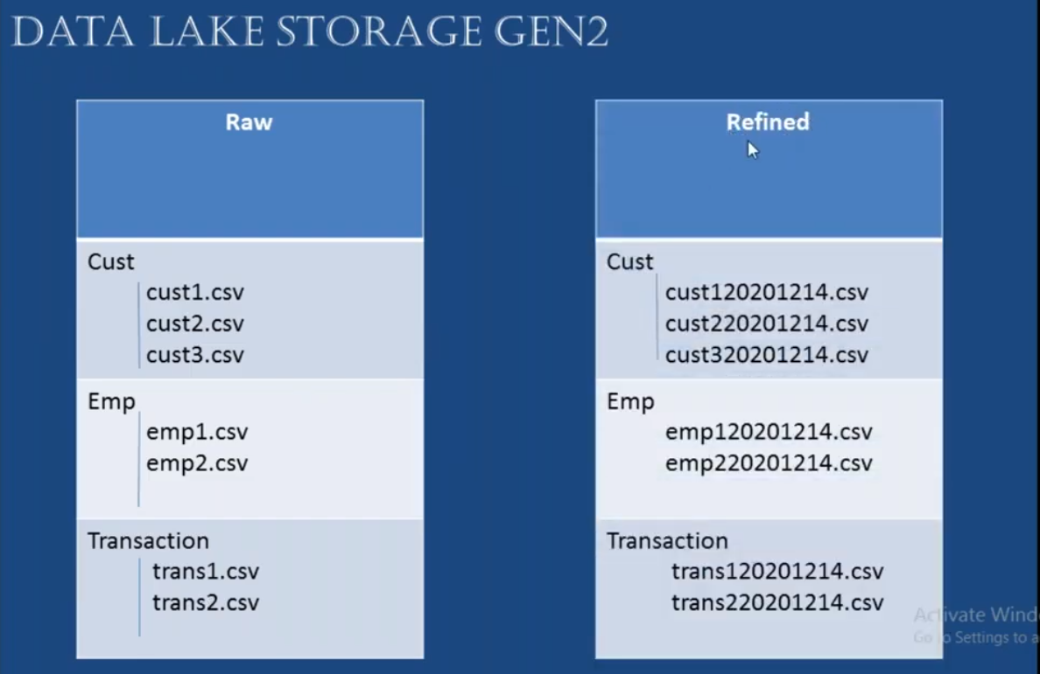
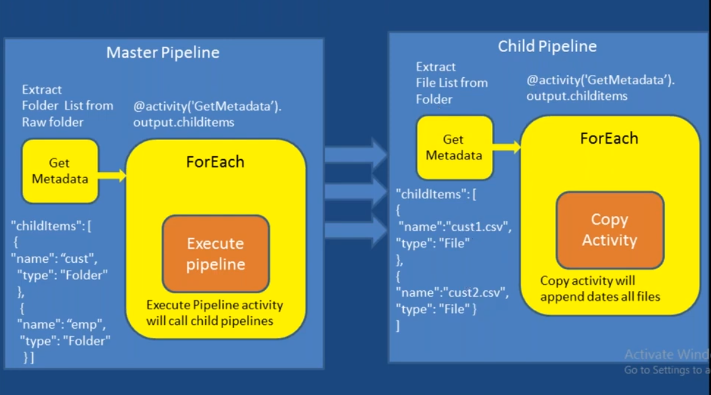
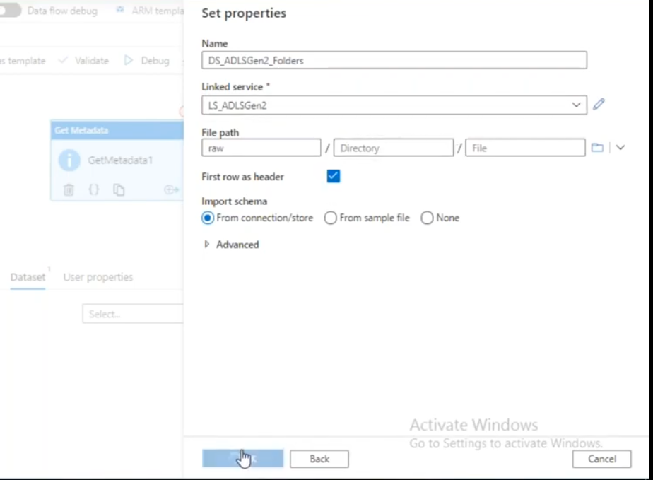
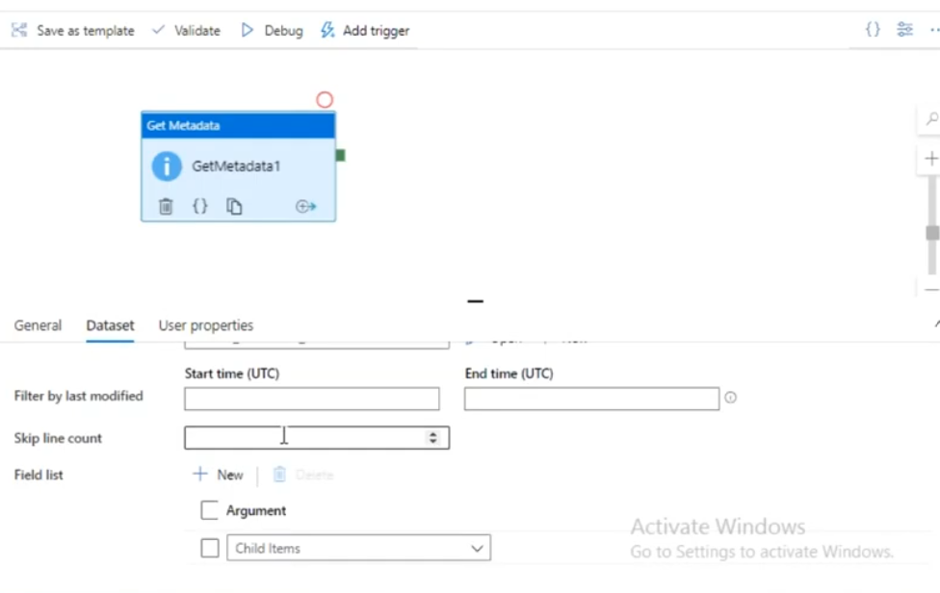
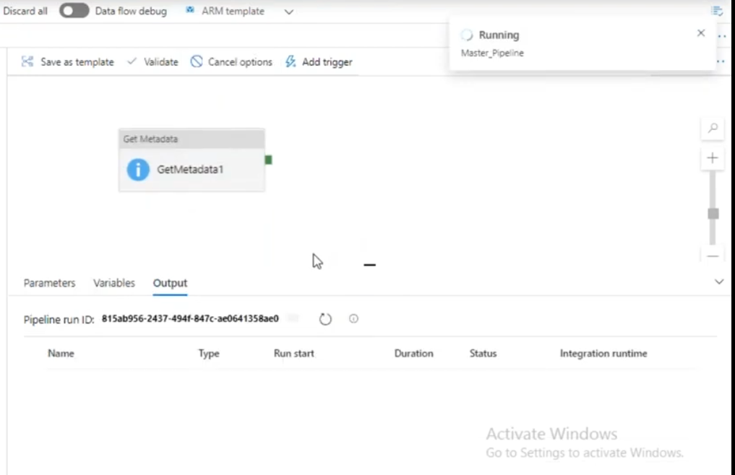
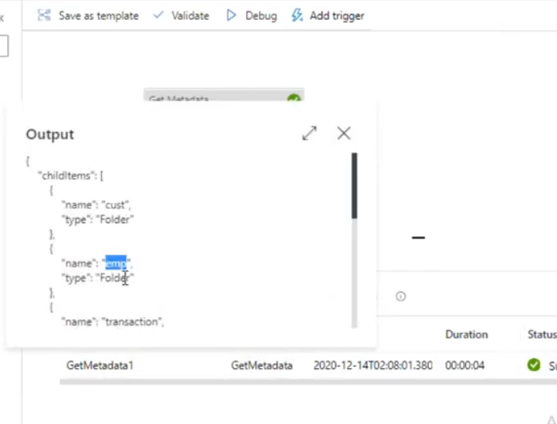
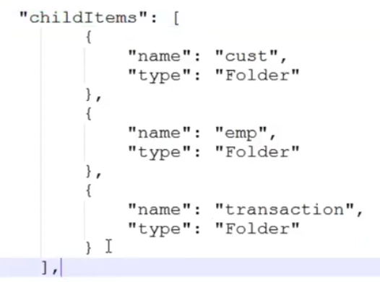
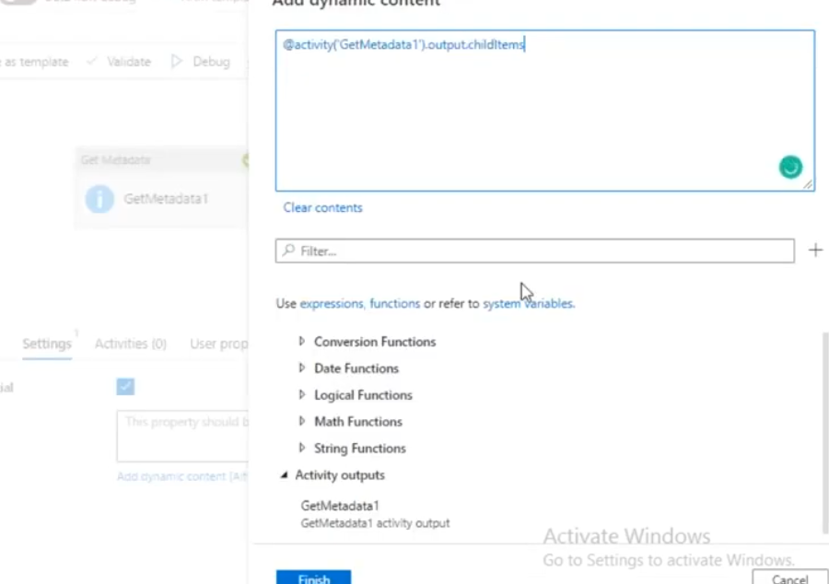
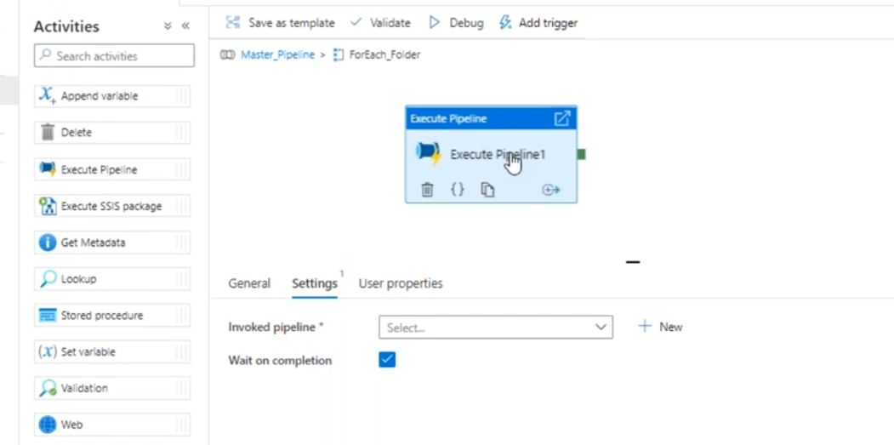
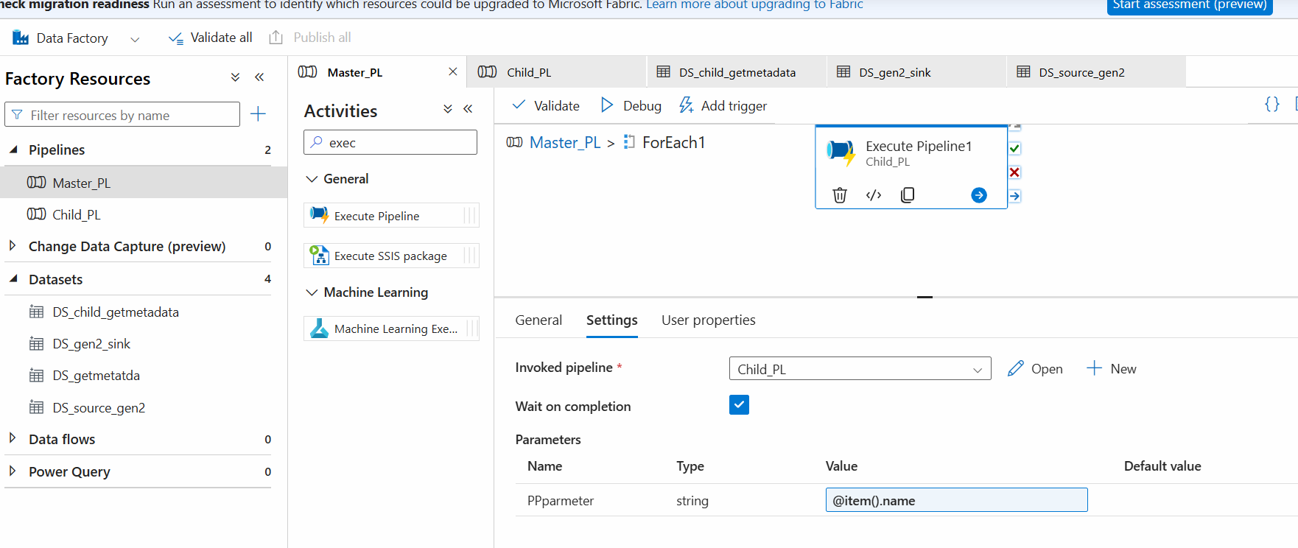
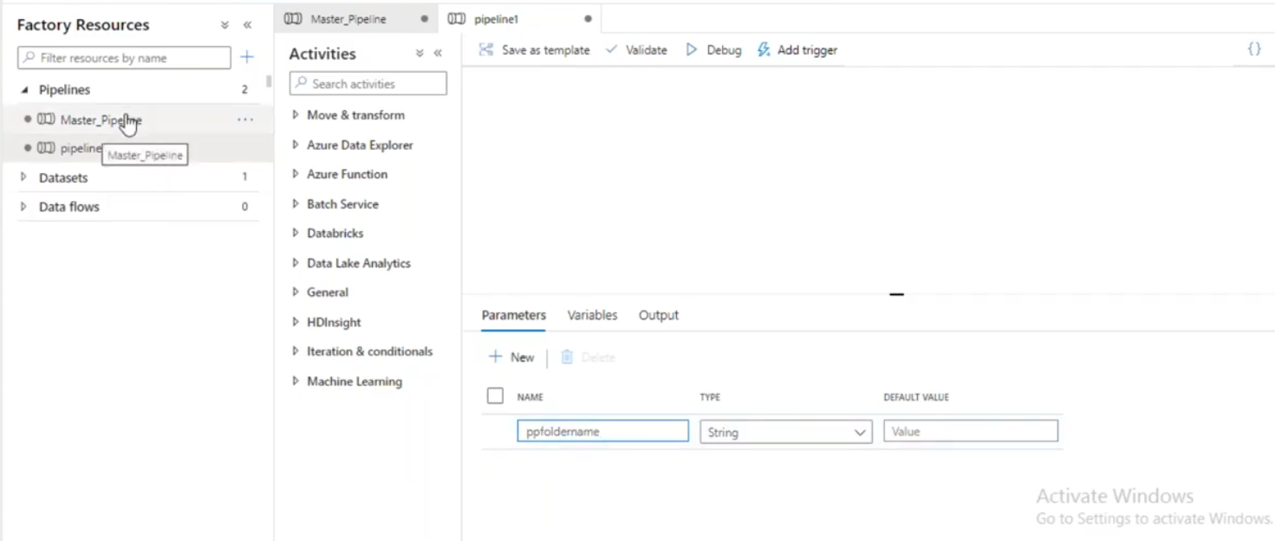
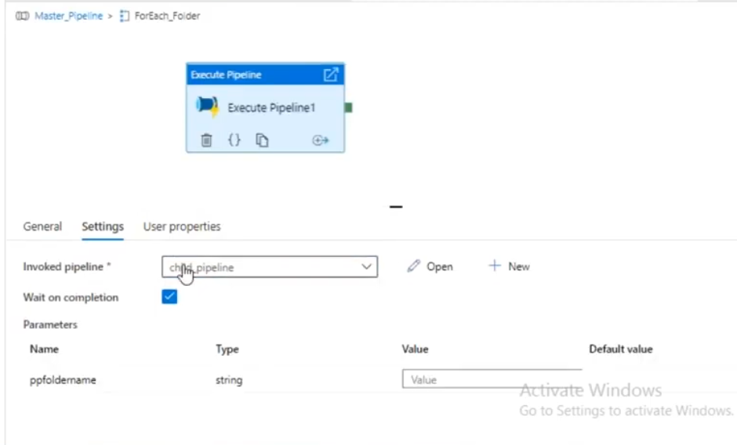

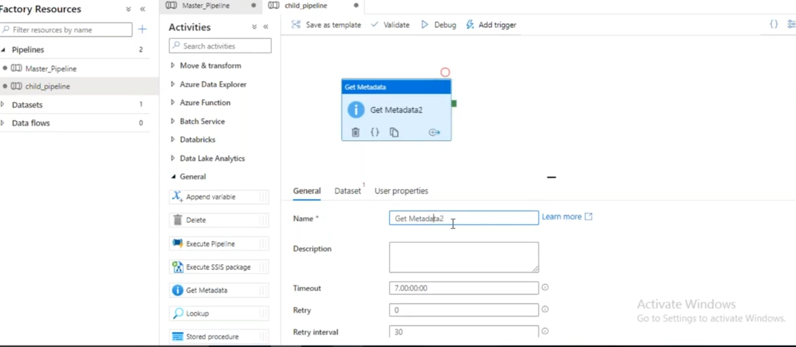

Don’t select any childitems here means getmetadata activity

Create dataset parameter
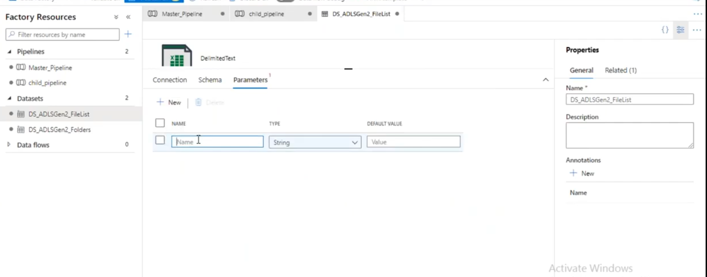
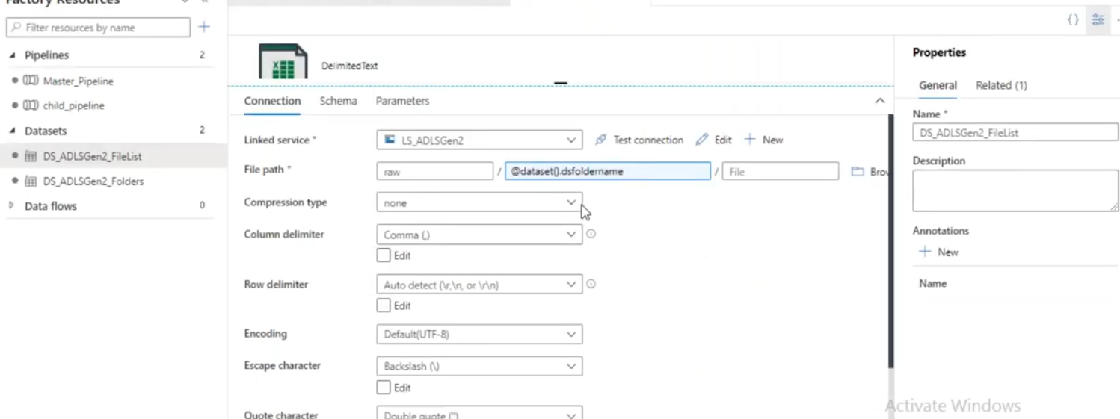
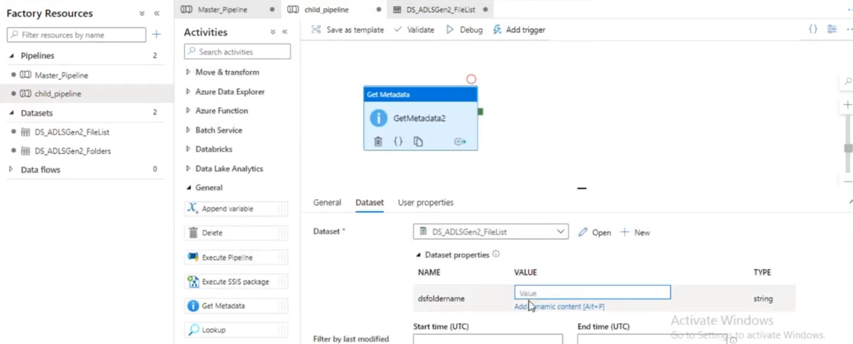
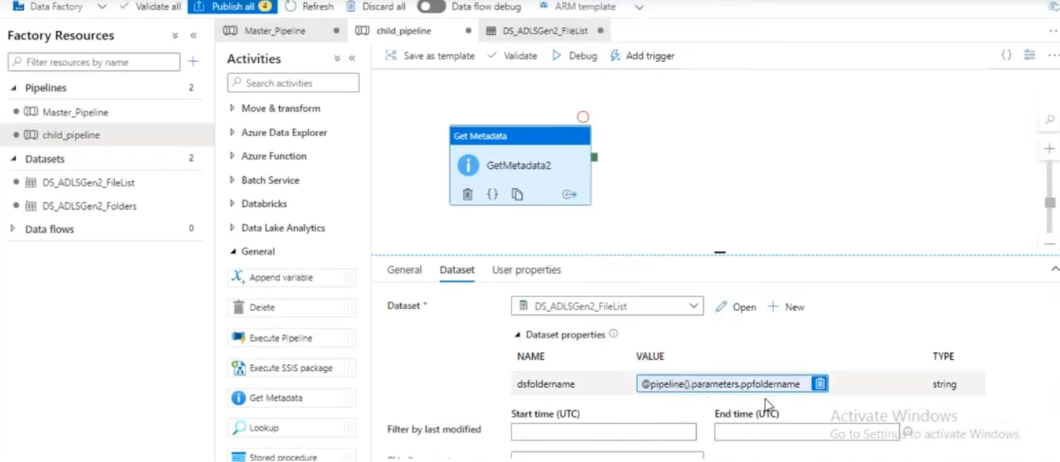
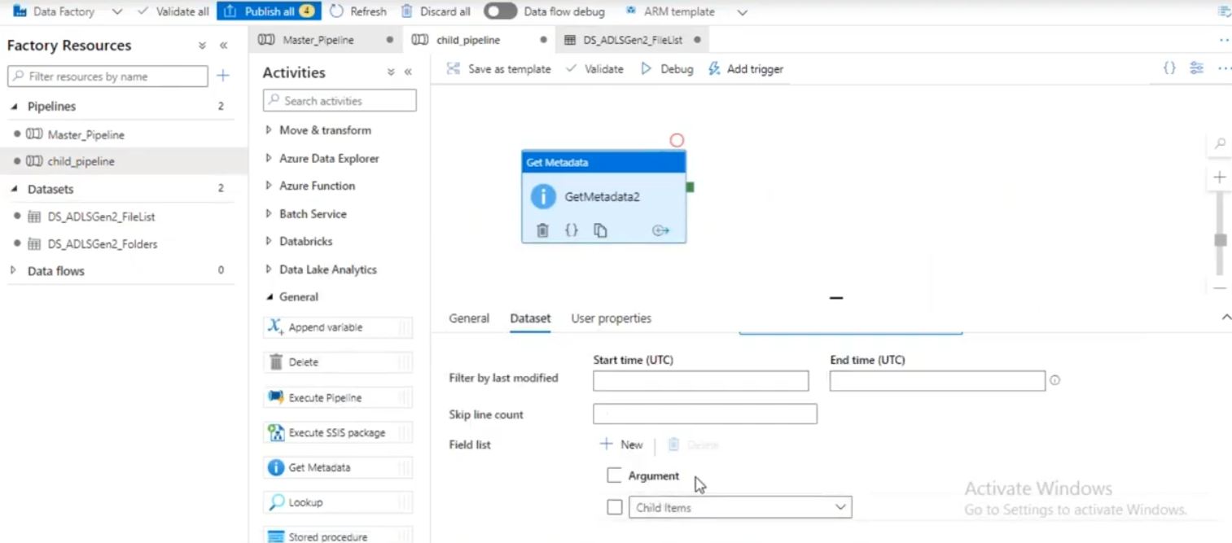
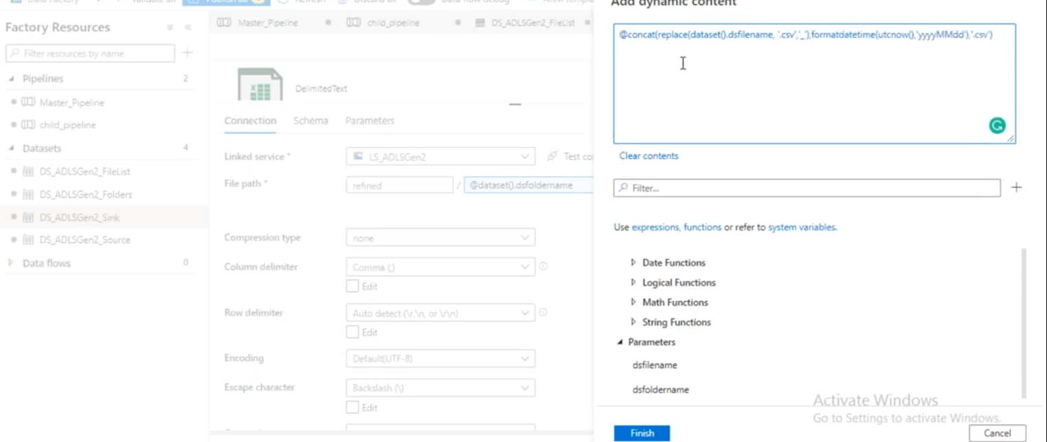.
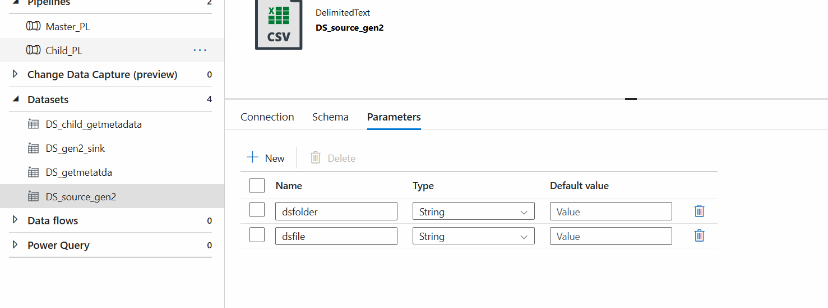
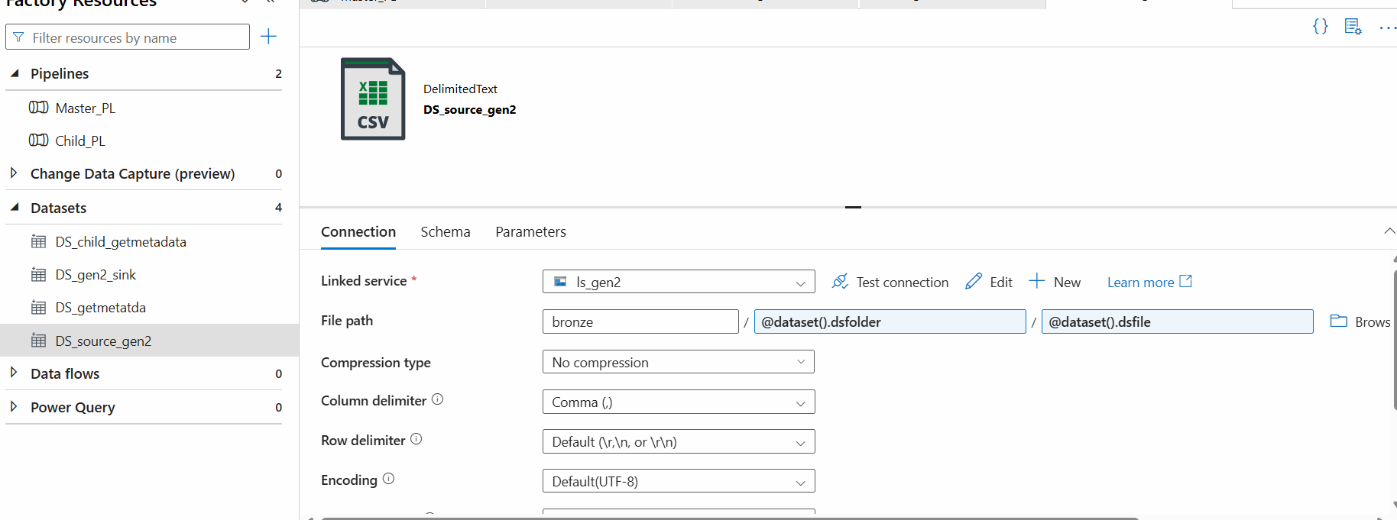
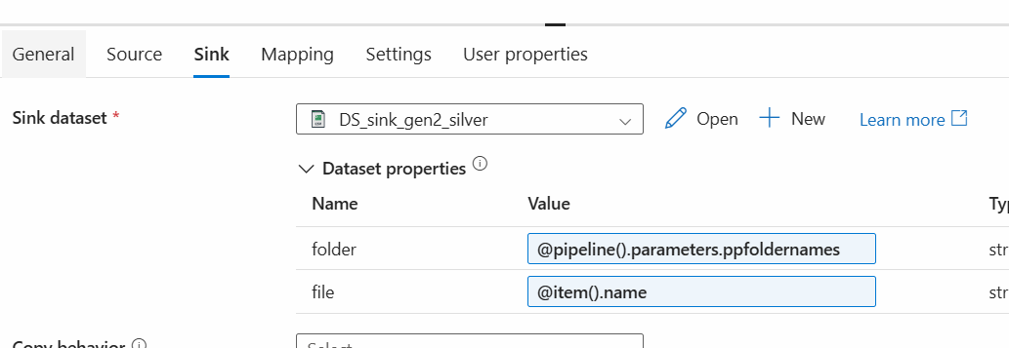
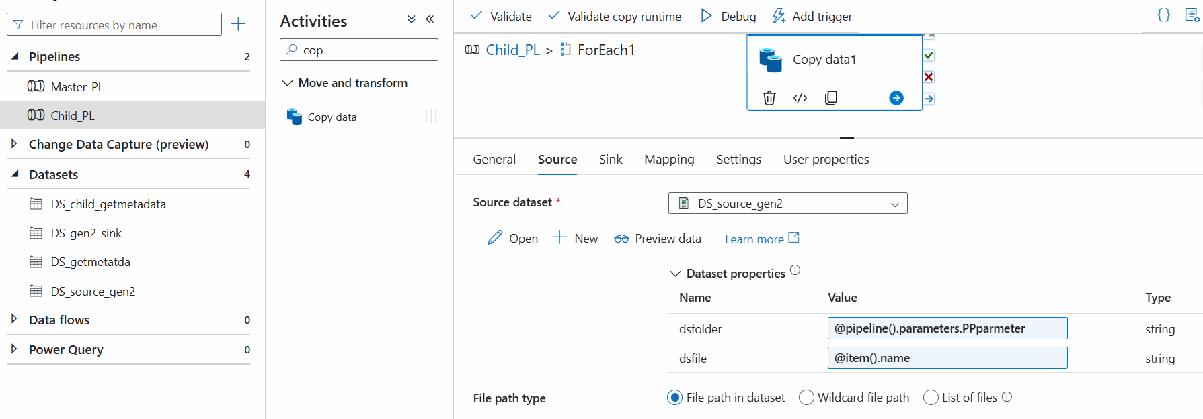

@concat(replace(dataset().dsfilename, '.csv', ''), '-', formatDateTime(utcNow(),'yyyyMMdd'), '.csv')

